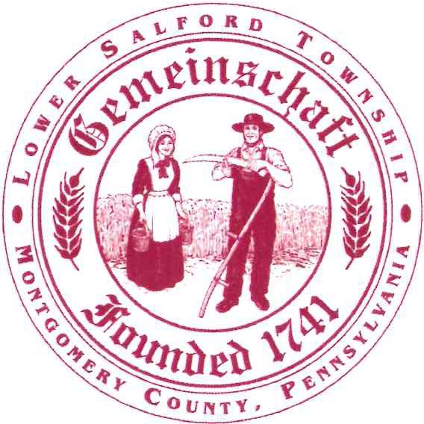

Lower Salford Township

Board of Supervisors
379 MAIN STREET
HARLEYSVILLE, PA 19438-2309

Road Improvement Program 2026

Cape Seal

Cape Seal is a 2-step pavement preservation process used to rehabilitate moderately distressed roadways. The first step is a chip seal where an asphalt emulsion is sprayed on the entire road surface and then immediately covered with small, crushed stone or “chips.” This process seals the existing road surface to prevent water penetration that can lead to potholes and pavement failures. After any loose chips are swept up, the second step is performed where an asphalt slurry is applied over the chip seal. This process locks in the chip seal and provides a smoother, more appealing finish coat to the road. This process cost approximately 1/3 of the cost of traditional milling and hot-mix paving, which allows the Township to stretch our road improvement budget.

List of roads (all or in part) that will receive cape seal surface treatment in 2026:
- Fairway Drive  - Fox Den Lane  - Orchard Lane  - Bellingham Lane  - Covenant Lane | - Carrie Lane  - Arrowhead Lane  - Marian Court  - Moyer Road (Main St to Oak Dr)
Work is scheduled to begin the week of June 29th, weather permitting, with the chip seal. The slurry process is tentatively scheduled for the end of July.

Ultra-Thin Bonded Wearing Course or “NovaChip”

NovaChip is another pavement preservation tool that involves applying a thin layer of hot-mix asphalt material over a heavy application of asphalt emulsion, which is what “bonds” the new asphalt to the existing pavement surface. This process is being used on roads that are in sound structural condition but have had multiple chip seal application over the years. The result is a smoother riding surface that is more durable than other pavement preservation techniques and costs about 25% less than traditional milling and paving. Some additional benefits are the open-graded texture reduces tire splash, hydroplaning and tire noise, and with the high virgin asphalt content compared to a traditional hot-mix, the roads stay black longer and are not as susceptible to oxidation and pavement fatigue resulting in longer life expectancy.

List of roads (all or in part) that will receive NovaChip in 2026:
- Oak Ridge Lane
- Cricket Lane
- Ruth Road (Clemens Road to Yoder Road)

No schedule is currently available for these roads.

Traditional Hot-Mix Paving

Groffs Mill Road/Indian Creek Road, from Harleysville Pike (Rt 113) to Freeman School Road, is the only traditional paving that will be done as part of this year’s program. Due to the volume and type of traffic this road receives, pavement preservation processes are not applicable. Work will include base repairs to correct structural concerns followed by surface milling of the entire road. Again, due to volume and type of traffic, it’s imperative to ensure proper adhesion of the new asphalt to the existing surface, and surface milling will provide a rough texture to accomplish this. Finally, a new hot-mix asphalt surface will be installed. In cooperation with Harleysville Materials, and a PennDOT grant the Township received, raised pavement markers (reflectors) and durable line striping will be installed to ensure the safety of the motoring public.

