Agenda
Lower Salford Township
Communication Committee
July 16th, 2025 @ 7:30 p.m.

- Call to order

- Call to approve minutes from the June 18, 2025, meeting – Chairperson

- Call for public discussion and visitor comments - Chairperson

- Old Business
  - Proposal to amend Resolution No. 2020-29 to add in Associate Members
    - Status Update
    - Committee to discuss membership of Residents vs. Business Owners
  - Giveaway Contest at Harleysville Market for Resident Engagement
  - “Township on the Go” discussion for local facilities
    - Review draft of online material request form

- New Business
  - Draft a recommendation on residential facility follow-up visits and special meeting sessions
    - Promote Township meetings/communications meetings at residential facilities, or a special facility focused session at the Township office
  - Exploring how to reach out to non-profits that serve the Township and let them know that we can be a resource for them

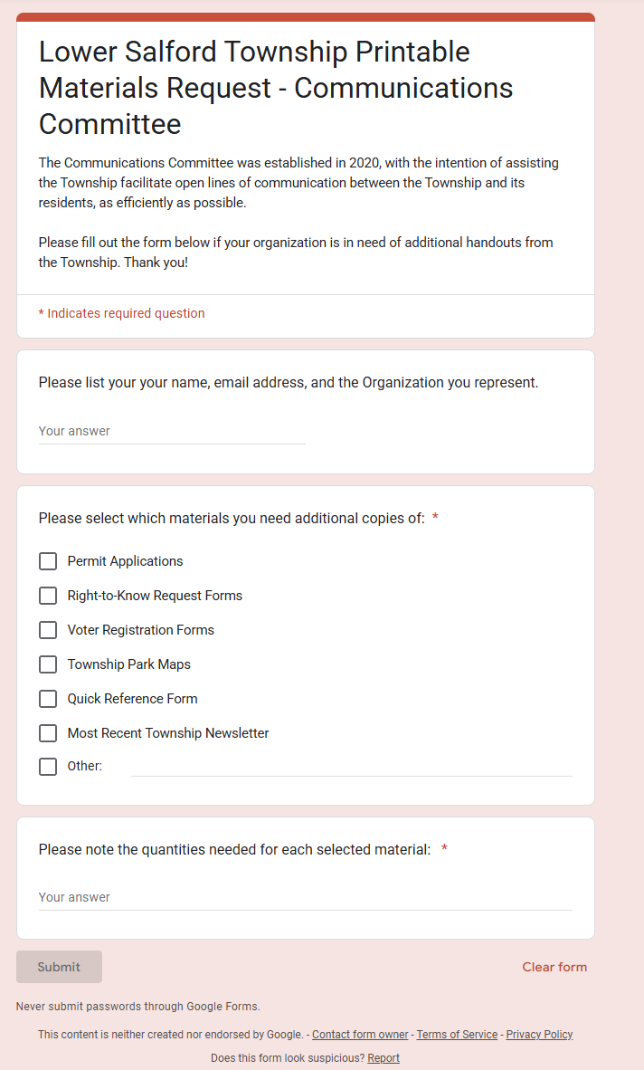
Closing

