Agenda

**Lower Salford Township**

**Communication Committee**

# March 19, 2025

# 7:30 p.m.

1. Call to order
2. Call to approve minutes from the February 19, 2025 meeting – Chairperson
3. Call for public discussion and visitor comments - Chairperson
4. Old Business
   1. Proposal to amend Resolution No. 2020-29 to add in Associate Members
      1. Pending approval from the Board of Supervisors
   2. Volume 3 updates to the Township Quick Reference Guide
   3. Review of Township website New Resident Guide page
   4. Draft a recommendation on residential facility follow-up visits and special meeting sessions
      1. Promote Township meetings/communications meetings at residential facilities, or a special facility focused session at the Township office
5. New Business
   1. New Resident messaging
      1. Confirm the next round of New Resident welcome letters
   2. Revisit Communications Committee’s core purpose per Township ordinance (Resolution No. 2020-29)
   3. Explore future topics / projects for the Communications Committee
6. Closing

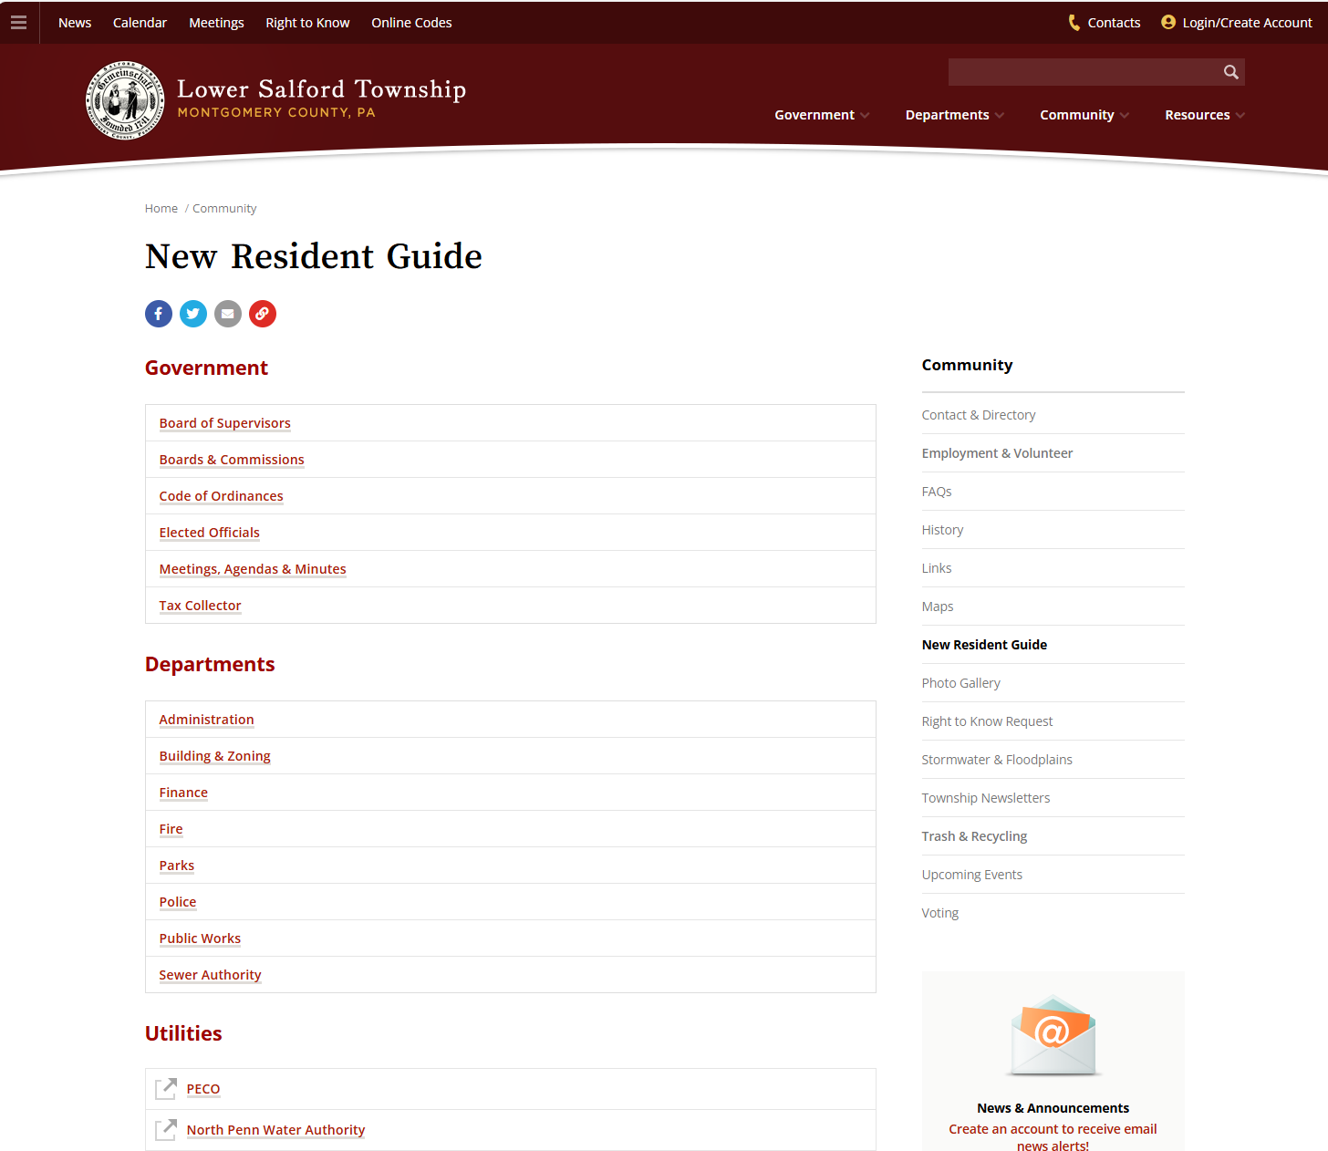

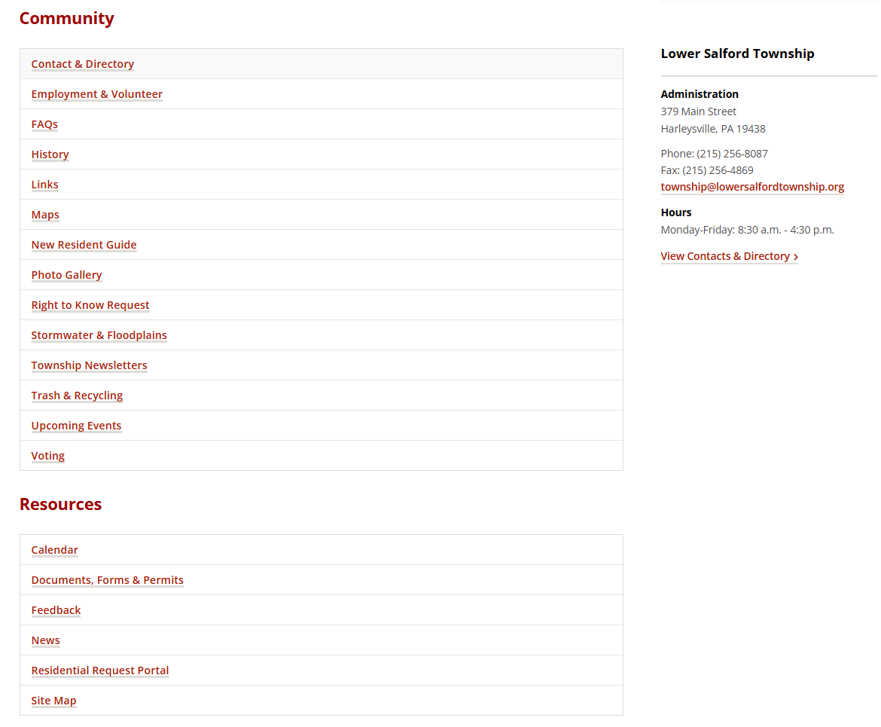

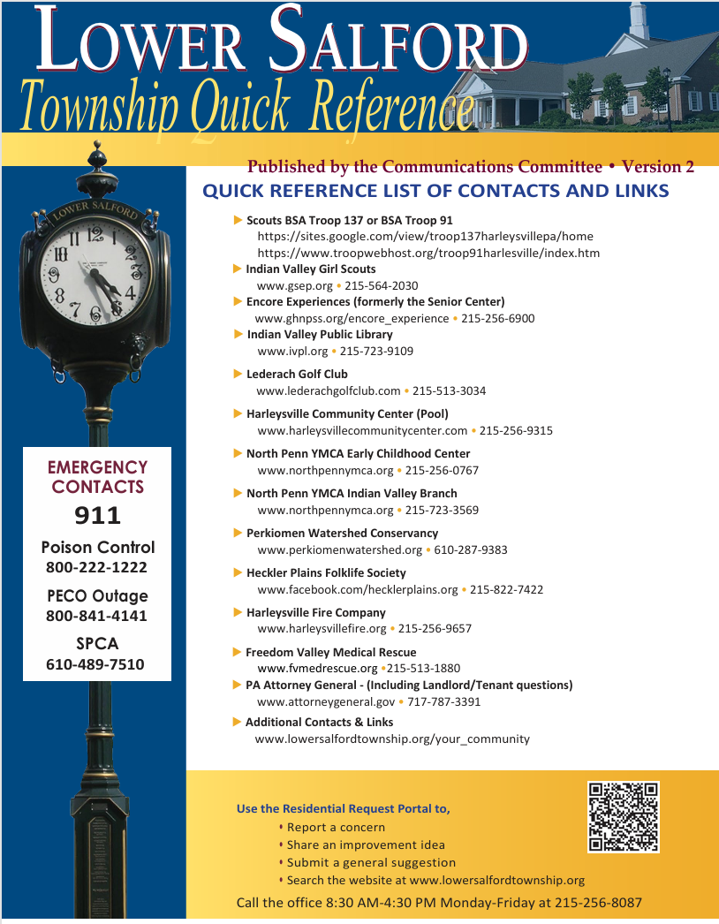

C**ommunication Committee topic backlog list**

|  |  |  |  |  |  |  |
| --- | --- | --- | --- | --- | --- | --- |
| Nbr | Rank | Title | Submitter Name | Submission Date | Description | **Comment** |
| 1 | 1 | Define Communications Committee brainstorming session | Committee | 10/20/2021 | Host a communications/special brainstorm meeting – for residents to participate in an open discussion with the communications committee |  |
| 2 | 2 | Draft a recommended Township subject matter expert speaker list | Committee | 10/20/2021 | Speaker list of township staff or committee members who could attend resident facility meetings – one or two SME for each committee or topic |  |
| 3 | 3 | Define how various communication channels might be used to publicize the Communications Committee and generate input | Committee | 4/20/2023 | Define a photo/drawling contact leveraging the various communication channels  Contest? |  |
| 4 | 3 | Define how the Township's communication channels could be used to encourage Communications Committee feedback | Committee | 10/20/2021 | Contest?  **Possible use of a survey,** |  |
| 5 | 3 | Explore options for additional resident outreach using various communication channels | Jean Campbell | 1/19/2023 | increase outreach to residents within the Township.  Contest? |  |
| 6 | 4 | Draft a recommendation on renter quick reference guide | Committee | 10/20/2021 | Top 10 list of Township contacts and services for renters |  |
| 7 | 5 | Draft a recommendation on the use of Dynamic QR codes | John Del Pizzo | 2/16/2023 | Dynamic QR codes for different township communication channels to track usage. Dynamic QR codes have the potential to provide information to the committee on how residents are the various communication channels. This may help the committee understand which channels are utilized the most by residents. |  |
| 8 | 6 | Draft a recommendation for a New Resident welcome video | Committee | 10/20/2021 |  |  |
| 9 | 7 | Define the parameters for a sessionwith the **outside organizations** | Committee | 10/20/2021 | Contact the Indian Valley Chamber of Commerce to see if they have a flyer or information for resident packet |  |
| 10 |  | Define how to measure the impact of the Communications Committee | Terri Ehrhart | 1/19/2023 |  |  |
| 11 |  | Re-Explore ways to increase the number of residents on the **Catapult** distribution list | Heather Entenmann | 1/19/2023 |  |  |
| 12 |  | Draft a recommendation on Township information videos | Committee | 4/20/2023 | Short videos tool to feature different township information |  |
| 13 |  | Brainstorm recommendations on increasing attendance and input to the Communication Committee | Committee | 9/18/2024 |  |  |
| 14 |  | Brainstorm uses for new Township communication channels  Facebook  Instagram | Committee | 9/18/2024 |  |  |
| 15 |  | Draft a recommendation for **contests** to encourage resident use of the various Township communication channels. | Kevin Shelly | 9/18/2024 | * Contest information and submissions via comms channels * Winning entries shared via comms channels * Winning entries to be displayed at the Township office * **Use the contest to encourage Resident use of other Township communication channels** |  |
| 16 |  | Draft a recommendation on a special Committee meeting with facility management companies | Committee | 9/18/2024 |  |  |
| 17 |  | Draft a recommendation on a Communication Committee meeting at residential facility locations | Committee | 9/18/2024 |  | **Supported by the BOS** |